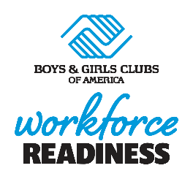

Sample full-time job Description
director of workforce readiness

Position objective:
To lead the planning and execution of a workforce development program and to provide the following services to teen participants: 1) improve employability of teen Club members, 2) provide career counseling, job readiness and job placement services, and 3) increase financial knowledge of teens. Serve as a “career mentor” to Club youth, providing individual and small group support to prepare them for employment and career development opportunities. Establish and/or expand relationships with local corporate and community partners that will contribute to the workforce development of Club teens. Work closely with Club and organization leadership to ensure success of the Club’s workforce development program.
Position Duties and Responsibilities:
- Build and maintain positive relationships with all Club teens
- Assist with teen recruitment initiatives to increase participation in the Club’s workforce development program
- Facilitate small-group workforce development programs/activities with all participants (e.g., CareerLaunch, Money Matters)
- Provide individual guidance to teen members about education and career pathways, resume/cover letter writing, mock interviews, personal branding, etc.
- Plan and coordinate opportunities for a variety of guest speakers to attend the Club and share their education and career pathway experiences
- Plan and coordinate off-site workforce development experiences for participants at a variety of workplaces
- Plan and coordinate workforce development-related community events (e.g., job fairs, job shadow events, workplace tours)
- With assistance from Club leadership, build a network of stakeholders and partners who can provide knowledge, skills development and experiential learning opportunities for members to help them secure employment opportunities
- With assistance from Club leadership, identify local organizations that need skilled employees; help develop a talent pipeline to benefit both Club teens and local employers

Education, Experience, Knowledge and Skills:
- Excellent written and interpersonal communication skills
- Organized and able to manage details efficiently and effectively
- Computer proficient, including MS Word and Excel
- Flexibility, patience, tolerance and willingness to learn new related skills
- Experience in youth development a plus

